Low Fat, High Fibre Cottage Pie

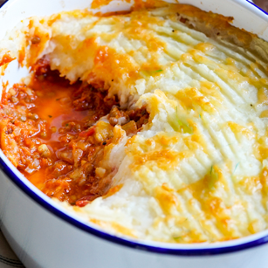

Ingredients

- 1 onion
- 2 carrots
- 3 celery sticks
- 2 garlic cloves
- 2 teaspoons dried mixed herbs
- 1 teaspoon cumin
- 1 tablespoon tomato puree
- 400g tin chopped tomatoes
- 250ml vegetable stock
- 2 tins of lentils drained and rinsed/or 1 tin mixed with lean mince/ or Quorn mince
- Salt and pepper
- Tablespoon of tamari or soy sauce

For the mash
- 4 potatoes peeled
- ½ head cauliflower
- 70ml plant milk or semi skimmed milk
- Knob of spread such as Flora
- 2 tablspsoons nutritional yeast (optional)
- Spinach or other green vegetable to serve

Method

- Preheat the oven to 220 C
- Put the chopped onion, carrots, celery and crushed garlic in a heavy pan.
- Cook over a medium heat with a splash of stock or water until soft.
- Add the cumin and tomato puree and stir well.
- Add the tinned tomatoes, tamari, stock and lentils or lentil mixture.
- Season with salt and pepper and simmer for 15.20 minutes.
- Make the topping, cook the potatoes and steam the cauliflower.
- Mash together with a little milk, spread, salt, pepper and nutritional yeast if using.
- Pour lentil mix into a baking dish, top with mashed potato.
10. Cook on the top shelf of the oven for 20minutes or until the mash is crispy and golden.
11. Serve with greens such as spinach, kale or broccoli

This is packed with adrenal supporting foods including lentils, sweet potato and vegetables to make you feel calm, happy and energised.

