Stress Busting Dahl

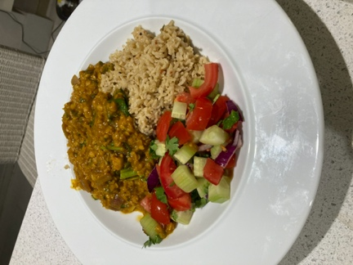

Ingredients

- 200g lentils (1 cup)
- 1 tablespoon rapeseed oil
- 1 red onion, finely chopped
- 1 clove garlic, crushed
- 1 3cm piece of ginger, peeled and finely chopped
- 2 teaspoons ground coriander
- 1 teaspoon ground cumin
- 1 teaspoon of ground turmeric
- ½ teaspoon chilli powder
- 1 tablespoon tomato puree
- 875ml of good quality vegetable stock
- 1 tablespoon fresh lemon juice
- I cup chopped coriander

Method

- Place the lentils in a sieve and rinse under cold, running water.
- Add chopped onion to a heavy pan with the rapeseed oil.
- Cook until the onion softens.
- Add the ginger, garlic, coriander, cumin, turmeric and chilli powder. Cook stirring for a minute.
- Add the tomato puree
- Stir in the lentils and stock and cook until the mixture thickens.
- Stir in the lemon juice and coriander.
- Serve with spiced brown basmati rice

This dahl is high in magnesium, fibre and protein. Perfect with just rice and a small salad or as part of an Indian meal. You can also add some greens like chard, kale or spinach at the end and serve when wilted.

