Buckwheat and Oat Granola

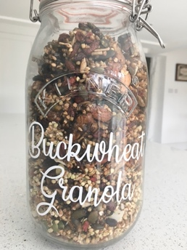

1 Cup (200g) Raw Buckwheat
2 cups Oats
1 Cup (160g) of Raw Almonds
½ cup Pumpkin Seeds
½ Cup Mixed Seeds (Flax Seeds, Sunflower Seeds, Sesame Seeds, Chia Seeds)
½ cup Dried Cranberries or Goji Berries
½ cup Medjool Dates, roughly chopped (About 4)
1 Tsp Cinnamon
2 Tbsp Maple Syrup
1 Tbsp Melted Coconut Oil
1 Tbsp Peanut Butter (optional)

Method

- Heat the oven to 150 C.
- Mix the buckwheat, oats, almonds, seeds and cinnamon together in a bowl.
- Melt the coconut oil with the peanut butter and maple syrup in a small saucepan.
- Pour over the oat and buckwheat mixture and stir.
- Place in two baking trays lined with greaseproof paper.
- Bake, stirring occasionally, for about 30 minutes or until lightly golden.
- Take out to cool and add chopped Medjool dates and Goji berries or some dried apricot

Buckwheat is actually a seed and is high in Protein and Fibre – it is also high in Magnesium to support bone health. it is also great source of Rutin which strengthens capillaries and veins.

