Watercress & Walnut Pesto Pasta

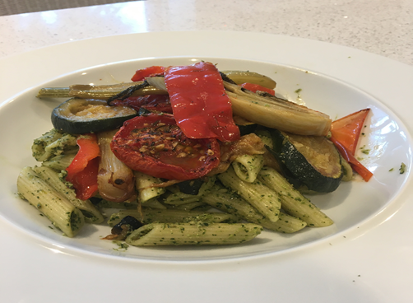

Ingredients

- 3 tbsp olive oil
- 80g watercress
- 1 clove of garlic
- 2oz/55g walnuts
- Juice of a lemon
- 2 tbsp nutritional yeast
- A pinch of himalayan or sea salt
- Black pepper

Method
- Place watercress, walnuts, lemon juice, nutritional yeast, garlic and olive oil in a processor or blender and blend until smooth.
- Stir into warm pasta and top with roasted vegetables.

Watercress and walnuts contain tryptophan which releases serotonin to help you sleep. Try to use whole wheat pasta or regular pasta that has been cooked previously and cooled. When it is cooled and eaten either cold or re-heated it contains resistant starch and doesn’t cause a blood sugar spike. Top with some colourful roasted vegetables or have with salad for an easy antioxidant rich, feel good lunch or dinner.
I have swapped traditional parmesan for nutritional yeast here to save on saturated fat. Nutritional yeast contains B Vitamins to help you cope with stress too.

