Gut Friendly Yoghurt, Chia and Berry Dessert

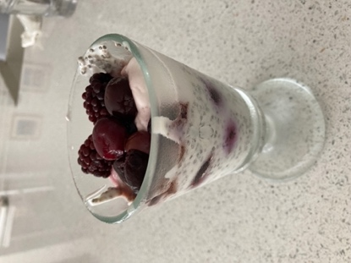

Ingredients

- 1 cup (or half a tub) of your favourite plain, full fat, live yoghurt
- 3 Tablespoons Chia Seeds
- ½ Cup of plant milk
- 1 Cup frozen berries

Method

- In a bowl, mix the yoghurt with the milk ( I used coconut yoghurt and almond milk)
- Sprinkle over the chia seeds and mix very well
- Layer some yoghurt mix then some frozen berries in a jar or glass bowls
- Leave in the fridge overnight or for several hours.

Chia seeds absorb between 9 – 12 times their volume, becoming gelatinous and making a pudding-type consistency and they are one of the healthiest foods on the planet. A great source of fibre, healthy omega oil, protein and they are also a great source of calcium, magnesium and phosphorus. With live yoghurt, this makes a very healthy gut loving dessert or breakfast.

