Creamy dill cucumber salad

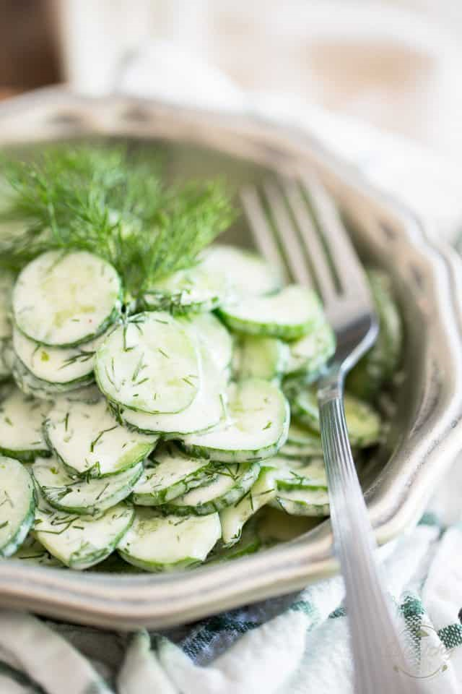
Ingredients
- 4 seedless mini cucumbers, thinly sliced
- 70g plain Greek yogurt
- 2 tbsp fresh dill, finely chopped
- 1 tbsp extra-virgin olive oil
- ½ tsp unpasteurized honey
- ½ tsp Dijon mustard
- ¼ tsp Himalayan salt
- ⅛ tsp ground white pepper

Method
- In a small bowl, combine all the ingredients, except for the cucumbers, and mix well with a fork.
- Pour over the sliced cucumber and stir delicately until well combined.
- IMPORTANT: cover and place in the fridge for at least 2 to 3 hours to allow flavours to meld.
- This salad will keep for up to 2 days airtight in the refrigerator.

From: https://thehealthyfoodie.com/creamy-dill-cucumber-salad/

