Chicken, kale & sprout stir-fry

Ingredients
- 100g soba noodle
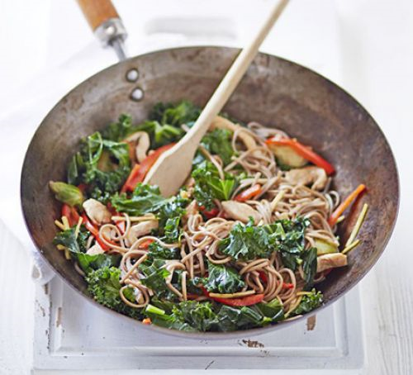
- 100g shredded curly kale
- 2 tsp sesame oil
- 2 lean chicken breast, skin removed and sliced into thin strips
- 25g piece fresh ginger, peeled and sliced into matchsticks
- 1 red pepper, deseeded and thinly sliced
- Handful Brussels sprout, cut into quarters
- 1 tbsp low-sodium soy sauce
- 2 tbsp rice wine or white wine vinegar
- Zest and juice 1 lime

Method
- Cook the noodles following pack instructions, then drain and set aside. meanwhile, heat a large wok or frying pan and add the kale along with a good splash of water and cook for 1-2 mins until wilted, with a little bite remaining, then cool under running water to keep the colour.
- Add half the oil and cook the chicken strips until browned, then remove and set aside. Heat the remaining oil and fry the ginger, pepper and sprouts until softened a little. return the chicken and kale and add the noodles.
- Tip in the soy, rice wine and lime zest and juice along with enough water to create a sauce that clings to the ingredients. Serve immediately.
From: http://www.bbcgoodfood.com/recipes/chicken-kale-sprout-stir-fry

