Celeriac salad with yoghurt dressing

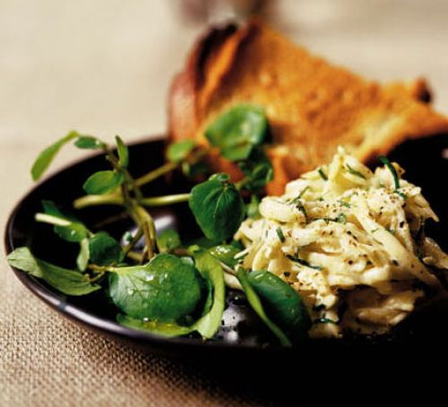
Ingredients
- 500g celeriac
- Juice of 1 lemon
- 2 tbsp olive oil
- 2 tbsp yoghurt
- 1 tbsp white wine vinegar
- 1 tsp English mustard
- Salt & pepper

Method
- Peel and chop the celeriac into matchsticks and put them into a bowl of cold water then add the lemon juice. Bring a saucepan of water to the boil and add the celeriac. Bring back to the boil, blanching the celeriac, then drain and rinse. Pat dry with a cloth.
- For the dressing put the oil, yoghurt, white wine vinegar, English mustard, salt and pepper in a jar, shake it up and mix with the celeriac.
Recipe from: https://bit.ly/2EE6Irc
Picture from: https://bit.ly/2IGd4dn

