Cabbage Soup
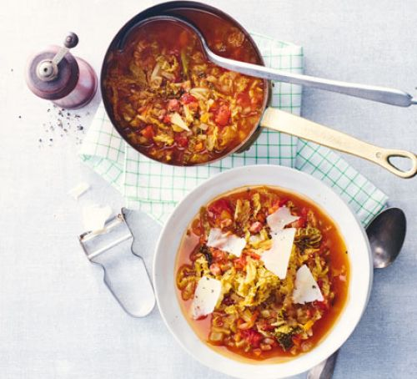
Ingredients: (serves 6)
- 2 Tbsp. Olive oil
- 1 Large Onion, finely chopped
- 2 Celery Sticks, finely chopped
- 1 Large Carrot, finely chopped
- 70g Smoked Pancetta, diced (optional)
- 1 Large Savoy Cabbage
- 2 Fat garlic cloves, crushed
- 1 heaped tsp. sweet smoked paprika
- 1 tbsp. finely chopped rosemary
- 1 x 400g can chopped tomatoes
- 1.7l hot vegetable stock
- 1 x 400g can chickpeas, drained and rinsed
- Shaved parmesan to serve (optional)
- Crusty bread to serve (optional)
Method:
- Heat the oil in a casserole pot over a low heat.
- Add the onion, celery and carrot with some salt, and fry gently for 15 mins or until veg begins to soften
- If using pancetta add this to the pan too
- Tip in the cabbage and fry for 5 mins, then stir through the garlic, paprika and rosemary and cook for another minute
- Tip the chopped tomatoes and stock into the pan.
- Bring to a simmer, then cook uncovered for 30 minutes, adding the chickpeas for the final 10 mins
- Season generously with salt and black pepper.
- Serve the soup with the parmesan and crusty bread if you wish
https://www.bbcgoodfood.com/recipes/cabbage-soup

