Brussels Sprouts with Pancetta and Chestnuts

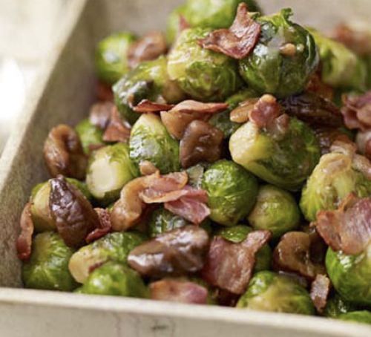
Serves 8

Ingredients
500g Brussels sprouts
Brussels sprouts, trimmed
140g diced pancetta
200g cooked chestnuts, broken into large pieces
1 tbsp light muscovado sugar
200ml vegetable stock

Method
Boil the sprouts for 3 mins until starting to soften slightly, then drain. Fry the pancetta until crisp, then remove from the pan and set aside. Add the chestnuts and sugar, tossing in the pan, then add the stock and reduce by half. Add the sprouts and pancetta back to the pan and warm through to serve.

From: http://www.bbcgoodfood.com/recipes/893647/sprouts-with-chestnuts-and-crisp-pancetta

